Alphabet in English
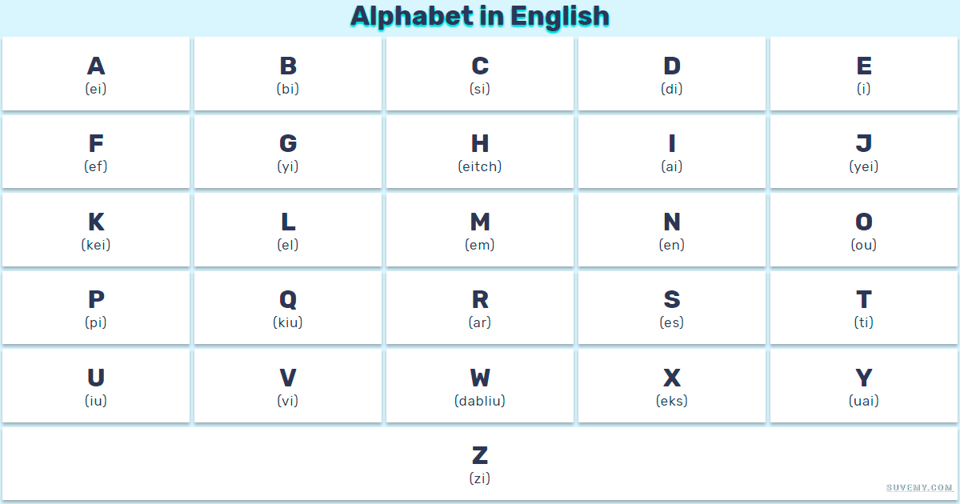
Colours
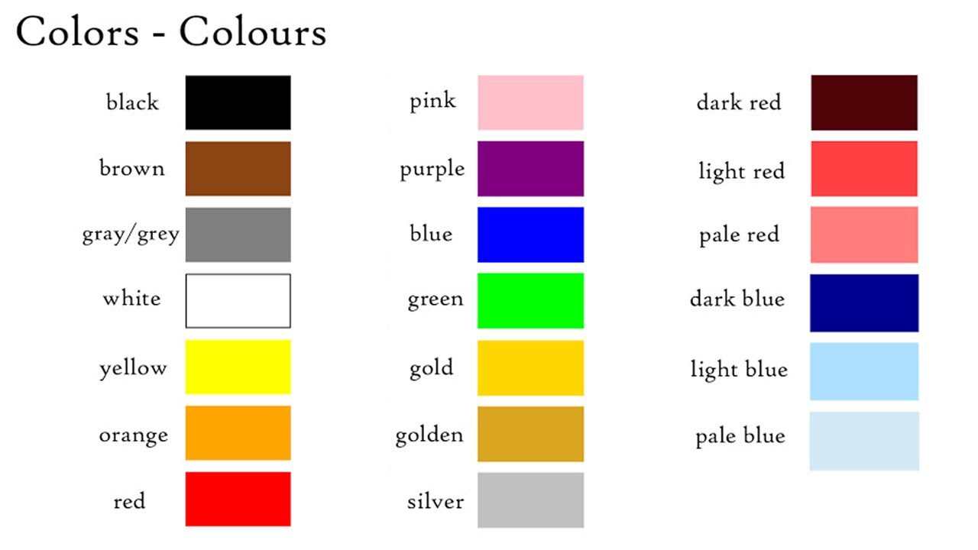

Numbers
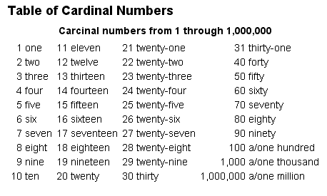
The Verb “to be”
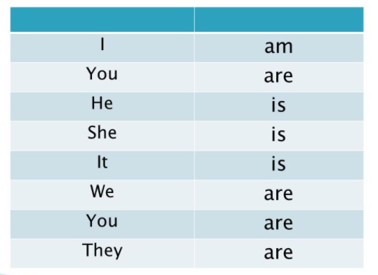
Activity: https://www.englishexercises.org/makeagame/viewgame.asp?id=717#a
Everyday Words
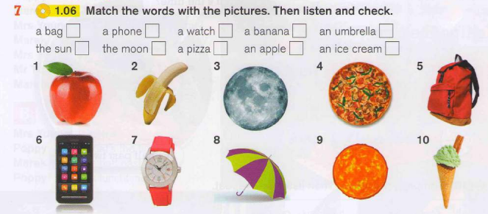
a + consonant | An + vowel | The + all letter

Activity: https://www.grammarbank.com/indefinite-articles.html

Classroom Vocabulary
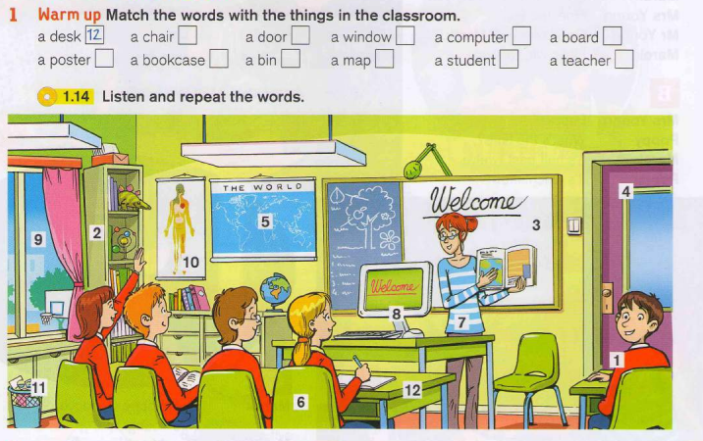
Activity
Question: How many windows are in the classroom?
Answer: There is one window in the classroom.
There are two/three/four windows in the classroom.

